Chapter 8
Analyzing The Impact of Covid-19 and Vaccination using Machine Learning and ANN Models
Abirami T^{1 *}, Akshita S ^{2 a)}, Annuncia Marena Y ^{b)}, Haritha M ^{c)}, Jayadharshini P ^{d)} & Madhuvanthi T ³

¹ Associate Professor, Department of Information Technology, Kongu Engineering College, Perundurai, Erode. abiananthmca@gmail.com

² Department of Information Technology, Kongu Engineering College, Perundurai, Erode. jayadharshini.p08@gmail.com
³ , Department of Computer Science and Engineering, Kongu Engineering College, Perundurai, Erode. madhuvanthi313@gmail.com
Abstract. The novel coronavirus epidemic was originally broken out at the end of December 2019, and it has now infected over 250 million individuals worldwide, killing over 5.08 million. At the end of January 2020, India, the first case was reported. By 6 June 2020, the number had risen to 0.24 million. The proposed method examines newly developed predicting models in-depth and forecasts the numerous cases of confirmed, recovered, and fatality caused through coronavirus in India. To improve the Covid-19 impact analysis, machine learning algorithms such as decision tree, multiple linear regression (MLR), random forest, Support vector Machine (SVM) and Artificial neural network model were utilized for enhancing precision. With an 0.9992 R-squared score, the projected number of cases matches the actual numbers quite well. Vaccination is a safer option for protecting and preventing the spread of this pandemic before it getting worsen. A follow-up on the vaccination and its effects is required for research and the development of new ways to protect us from the disease. There hasn't been any research done on the effects of vaccination. The data following immunization is analyzed using machine learning methods. Also, using Xgboost, the accuracy has been improvised. Importing the matplotlib package is used to visualize the covid19 data. Finally, before and after the vaccine, a performance analysis was implemented. According to the verdicts, Lockdown and social distancing are the two crucial characteristics which can ease the elevated rate of covid19.
Keywords. COVID-19, Machine Learning, SVM, Linear regression, Random Forest, ANN, Vaccination Analyses.
- Introduction
Humans are well familiar in technological progress they are dealing with many problems such as climate crisis and many natural crises. Among these a new virus evolved to succeed the infecting humanity. The World Health Organization (WHO) has declared this new pandemic disease as coronavirus which grows as outbreak pandemic disease. This pandemic virus gets transmitted by perspective of sources such as from infected person to a normal person. This disease would cause serious effects to a normal human life as well as to the society. At initial stage, there is no medicines or specific treatment to fight against this pandemic disease. But now a days the vaccinations are identified to fight against the present structure of the coronavirus and also protects the infected person from serious affects. Though the vaccinations are identified the coronavirus is changing its structure as the day passes. According to its changing structure humans are taking the vaccination dose with different criteria’s. So, the designation of new covid vaccines are much needed even though the present anti-viral drugs are in current use to treat COVID affected patients. Until the appropriate medicines are identified to cure coronavirus the global death rate cannot be controlled and they can be minimized by using this drug. The strict rules should be followed by the government to avoid the community transmission of COVID-19. Person to Person transmission can be minimised by following social distance, wearing mask, using sanitizer and avoid crowd in public places. It is the responsibility of public health authorities to regulate the monitoring status of outbreak frequencies as well as public should cooperate to the meaningful measures.
Among the spread of human to human, the pandemic affect between human to animal is a threatening issue. Humans have a knowledge to use all technical methods to avoid covid 19. So, humans can safely guard the animals from the pandemic disease. To monitor the above-mentioned pandemic disease in different areas in the state the machine learning technique is introduced. Not only is the affected rate, vaccinated rate in the particular region also monitored. The persons who are affected even though they were vaccinated is also gets monitored. All over infected rate, death rate, vaccinated rate is studied to take accurate responsibilities in more affected region. For this accuracy measurement various machine learning algorithms are used and various performance metrics are being calculated by using statistics hypothetical measurement. Though Machine learning technique is widely used for forecasting which is used to improve decision making approaches in different fields. In addition to the above approach machine learning algorithms play a major role in robotics, natural language processing, images, voice processing, etc. Machine learning technique have a unique procedure which is opposite to a traditional language related to the conditional statements.
SARS-CoV-2 was reported to World Health Organization, with an unknown origin in Wuhan- China, in December 31^{st,} 2019. [1]On 7th of January, 2020, authorities of Wuhan identified a different virus of SARS as the cause, which was given the temporary designation “2019-nCoV”. On 11th of March, it is declared as a global outbreak. [2]According to pathologists, COVID-19's virus bears a striking resemblance to the coronaviruses that cause Middle East Respiratory Syndrome (MERS) and Severe Acute Respiratory Syndrome (SARS). [3] & [4] It is the sixth member of the coronavirus family that may spread among humans and is easily transmitted from one person to another through droplets from coughs or sneezes. Fever, cough, respiratory distress, and diarrhoea are the utmost common warning sign of COVID-19 infection. The main issue with this disease is that once an individual is infected, symptoms usually develop within 2 to 14 days. The incubation period is the time it takes for a virus to develop, and the average quarantine is about 5 days. During the incubation period, a diseased one might contaminate a large number of active people. These people are asymptomatic, and identifying them is a huge difficulty. The transmission rate (R) is the leap of one affected person spreads the virus to further. [5]It is predicted to be between 1.5 and 3.5 in recent studies by top research organizations. In comparison with SARS (2.0) and the ordinary flu (1.3), this rate of transmission is quite high, making it extremely deadly.
In India, currently 34 million confirmed covid cases has been reported i.e., approximately 25k cases with 335 death cases are reported per 1 million people. But, COVID-19 can be protected with immunization, however no vaccine is 100 percent effective, therefore "breakthrough infections" are inevitable. The CDC, which stands for the Centers for Disease Control and Prevention in India has been tracking the frequency of breakthrough infections,[6] & [7] which are defined as cases in which SARS-CoV-2 is discovered in a respiratory specimen 14 days or more after an individual has received all recommended vaccination doses. In India, the Vaccination drive was initiated on 16th Jan 2021. At first, people who are all above 18 years of age are eligible for the vaccine. 5000 breakthrough infections were recorded from 29 states between January 1 and April 30, 2021. At the time, 101 million people in INDIA 28.1Cr had had full COVID-19 vaccination. In comparison, during the same time period, 6 million COVID-19 infections were reported, therefore these vaccination breakthrough infections were a minuscule percentage of the total. Importantly, not everyone who had a breakthrough infection felt sick; in fact, 27% of those who had a breakthrough infection were asymptomatic.
- Literature Review
[8] using multi-linear regression to examine the available data, the COVID-19 epidemic in several Indian states remained expected to expand, recover, and die., the correlation coefficient, and the Auto-regression technique to improve accuracy, as well as forecasting confirmed instances for the following 30 days. They use the same dataset to determine and calculate the degree of variables. It has analysed the Covid19 outbreak using Time Series Prediction Model. [9] compared morality and recovery rates, used k-means clustering to group the most of confirmed and deceased counts, which has upsurge and deterioration of confirmed cases, deceased cases and recovered cases in the top 15 nations. Inertia is calculated by the total number of squared errors for the clusters respectively. They assessed the results using the Elbow and Silhouette Scores, as well as calculating the risk factor and optimising treatment options for the patients.
Cytokine is the forecasting [10] of rate of mortality in COVID 19 affected people. This paper computed the paradigm of one month cycle of mortality grounded on the stages of serum of interleukin6 (IL6), tumour necrosis factor alpha (TNFα), interleukin1β (IL1β) and interleukin8 (IL8), are constrained by future-generation of ELISA. IL6 predicts the transience at the cut-off value of 163.4 pg/ml, with a true positive rate as 91.7% and true negative rate as 57.6%. The data used for this paper has been attained within 154 days i.e., starting from 22nd of January 2020 to 24th of June 2020. [11]paper determined that the covid case may rise for the next 60 days using Polynomial Regression Algorithm and SVM, but comparing to both the algorithms, svm illustrates the highest accuracy of about 93%. The study puts forward various trends and patterns experienced in different parts of the world. [11]The data to be studied has been obtained for 154 days i.e. from January 22, 2020, till June 24, 2020. Two Machine Learning models were used but in future Deep Learning models or hybrid two or models can be used to forecast the further spread of the virus. Real-time data has been used for this analysis and not the conventional data because the data validity of real time data highly depends on the time and its response time requirements come from the external world.
[2] has compared interpretation of expert system algorithm in forecasting the death rate of cardiovascular disease from the covid. [12]To maintain and manage the data they used Bigdata analytics, machine learning algorithm technology. The paper concludes that the most important reason of covid19 death is because of DKA and cardiovascular patients. Forecasting the number of future cases,[13] uses non-linear predicting algorithms to predict the dynamics of covid19 for ten countries around the world, which includes Germany, Brazil, China, Italy, Spain, UK, India, Israel, US, and Russia, using Deep Learning algorithms such as LSTM, GRU, and BI-LSTM, and evaluating the algorithms by finding Mean absolute error, Root mean square error, and r2_ score indices.
The mean square error, root square error, regression score, and % accuracy was determined using the SVM model with radial basic function. [14]They forecast the total sum of number of COVID19-infected cases, emerging cases, the number of fatalities, and the daily new deaths. The findings point to a Gaussian reduction in the number of cases.[15] Based on the notion of machine learning, the researchers estimated the total number of cases, retrieved cases, and deaths across a given collection of data and visualized the future prediction of disease side effects. They used a graphic model to depict where vaccination takes place and how many people are immunized. [16]a machine learning based COVID-19 cough classifier which can discriminate COVID-19 positive coughs from both COVID-19 negative and healthy coughs recorded on a smartphone. Many classifiers has been implemented but the best performance was exhibited by the Resnet50 classifier, able to discriminate between the COVID-19 positive and the healthy coughs with an area under the ROC curve (AUC) of 0.98.
[17]the paper involves in the detecting COVID19 occurrence using blood tests by know if people are infected by COVID-19 or not. Random Forest (RF), Support Vector Machine (SVM) and Naive Bayes are approached here. In that, SVM classifier achieved the best accuracy. The accuracy of PCR is 80%, and it is expense relative to the blood tests, and using our model we achieved a better result than the PCR. Machine learning (ML) based forecasting mechanisms is used for covid19 future forecasting predictions. [18]The ES performs best among all the used models followed by LR and LASSO in forecasting the new confirmed cases, death rate as well as recovery rate, while SVM performs poorly. Three types of predictions are made by each of the models, such as the number of newly infected cases, the number of deaths, and the number of recoveries in the next 10 days.
[19] Ml techniques enabled for the creation of disease prediction models and artificial intelligence techniques to analyze clinical parameters. And developed two classification models: the first classifies the test results for patients with suspected COVID-19, and the second classifies the hospitalization units of patients with COVID-19, both according to the laboratory parameters. The models achieved an accuracy above 96%, showing that they are promising to the classification of tests for COVID-19 and screen patients.[20]performed a comparative study of five machine learning standard models like Linear regression (LR), decision tree, least absolute shrinkage and selection operator (LASSO), random forest and support vector machine (SVM) to forecast the threatening variables of COVID-19. Each of the models makes three forms of forecasts, i.e., the total active cases, the total deaths, and the total recoveries in the next five days. For better accuracy they used a six-degree polynomial. Experiment results illustrate that poly LR and poly LASSO gives the best results followed by LR, LASSO, random forest, and decision tree. SVM shows the poor result in the prediction.
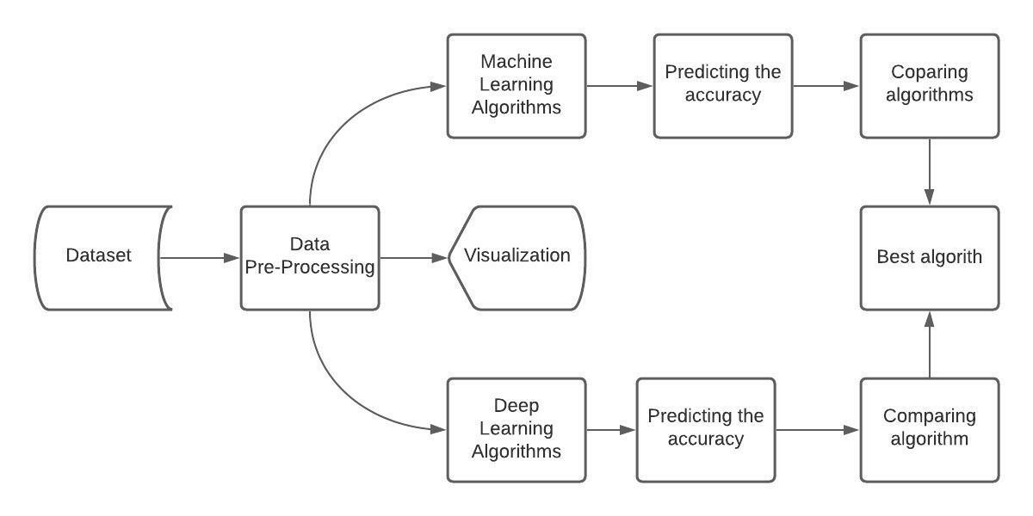
- Methodology
FIGURE.1 Process flow diagram
This research uses current coronavirus data from around the world to analyse the future report. Leveraging the concepts of machine learning and artificial neural networks (ANN) to accomplish this. Also, India is conducting a vaccination campaign; goal is to demonstrate which states are participating in the vaccination campaign and to do an analysis of deaths, recovered cases, and confirmed cases before and after vaccination using a graph model. FIGURE.1. shows the working process of analysing the impact of covid-19 and its vaccination using Machine learning and deep learning approaches. Initially, a dataset is downloaded, and pre-processing were done. Then visualization of the data available in the datasets are performed. After visualization analysis, prediction of the covid and its vaccination cases are performed in both Machine Learning and Deep Learning (ANN). After comparing, the algorithm and ANN model, best algorithm is chosen for covid prediction and its analysis.
- Dataset Description
The dataset used for analysing is taken from the JHU CSSE COVID data which will be daily updated on hourly basis. It consists of number of covid cases confirmed, recovered and also its deaths. It also has number of people get vaccinated and samples taken for testing. For analysing purpose, January 2020 to July 2021 dataset have been taken. It has 16383 rows and 7 rows with the data from 42 states and union territories. The column consists of date with hourly basis, country’s state - territory, confirmed Indian national, Covid-recovered, covid-death and covid-confirmed.
1.5 Data Preprocessing
Data pre-processing is a type of data mining that transforms unstructured data into a usable and effective shape.[21] In every expert system, pre-processing is the stage where the data is processed to remove the inconsistent data, or prearranged, so that the machine can parse it rapidly. To put it another way, the algorithm can now easily comprehend the features of the data. Data is typically gathered from a variety of sources that aren't always reliable, and dealing with quality of the data takes longer time while working with various algorithms of machine learning. It's simply impractical to suppose data to be without zero error. Data errors can be caused by human error, flaws in devices, or any processing system. Missing values in a data set are fairly common. It may have existed as a result of data processing or even a data validation law, but it must be considered regardless of missing numbers. Here, we'll apply the statistical mean method. This technique is used to get the mean value for each column, and NAN values are replaced with the mean values. Real-world data is occasionally partial or inaccurate, and it frequently lacks trend and specific characteristic information. Its primary function is to organize raw data. So, it's only then that machine learning approaches can be applied.
1.5 Data Visualization
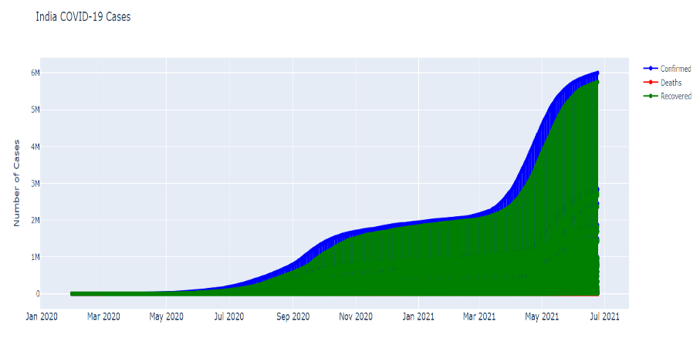
For covid19 data, a library called Matplotlib was imported to visualize the processed data. The data visualization of analyzing includes the top 10 states which has most death cases, recovered cases and confirmed cases from the dataset from January 2020 to July 2021. Then the comparison between various states has been calculated and sorted from largest to the lowest recorded cases.
FIGURE.2 India Covid-19 Cases

From FIGURE.2, it can be visualized that covid cases gradually increases from March 2021 and reaches at its maximum at July, 2021. Not only the covid cases, death rate related to the covid cases also approximately to the confirmed cases. But the recovered cases give a relief, that number of people recovering was in huge. The Race between total number of cases and Recovered cases on a daily basis in India. Also included is a performance analysis of covid19 data and immunization data. Finally, a chart comparing before and after immunization was created. From FIGURE. 3. a, b & c, gives an understanding to the top most states which has high amount of covid confirmed, death and recovered cases.
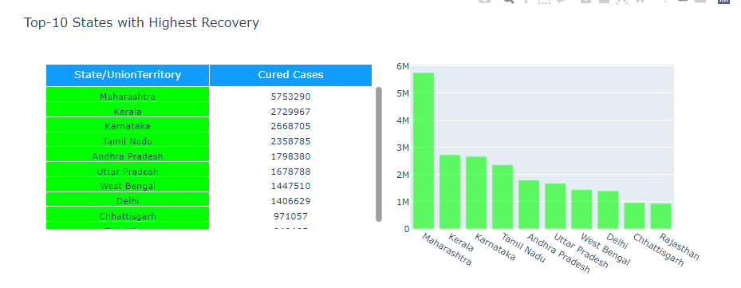
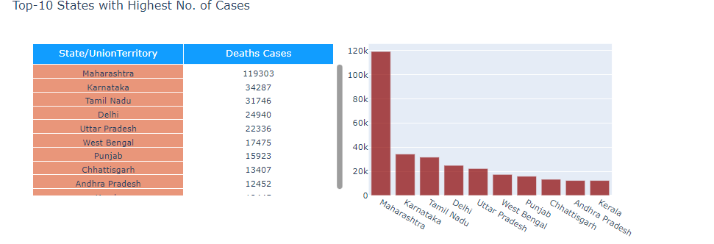
FIGURE.3.a Top States with Highest No. of Confirmed Cases
FIGURE.3.b States with Highest No. of Death Cases


FIGURE.3.c States with Highest No. of Recovered Cases

1.6 Prediction-Analysis Models
MLR is significant among regression algorithms, that shows the direct relationship within a particular dependent continuous variable to more than one independent variable. In MLR, the target(y) must be real/continuous, and predicting (x = x_{1,} x_{2, X3…}) can be in categorical or continuous form. It fits a line of regression by the multidimensional data points. But there is no correlation between the predictor variables. The general equation of MLR is given as,
y=A+B₁x₁+ B₂ x₂ + B₃ x₃ (1)
To solve classification and regression problems, machine learning method called Random Forest is used. In random forest classification, employ ensemble method to run solutions to complex situations. It is similar to decision tree, i.e., it has many sub-divided decision trees. [22]It trained with the aggregation of boosting and bagging methods. In random forest, root nodes and sub nodes are selected randomly. It has features and observations while splitting the node. As in random forest regression, dependent variables and independent variables are fed into the forest model. The regression function is given by,
y=bx+c (2)
where, x is an independent feature variable, y is a dependent feature variable, b is a parameter of estimator, and c is a constant. The output is finalized by the class of decision tree mode. Decision tree is generally used to represent and visualize the real-world problems decisions and its outputs. It can be used for both classification and regression. [22]It uses a tree like structure to visualize the predictions. It consists of root node and leaf node. Nodes in tree represents data. This is known as classification tree or if-then rules. If it has continuous outcome, then it is called as decision tree regression trees. It can be created by association rule. A node is selected by entropy, gain-ratio and information gain and it can be calculated by,
E(X,Y )=$\sum_{n ϵ X}{}P\left(n\right)E(n)$ (3)

E(Y) = $\sum_{i=1}^{n}{}- Pi Pi$ (4)

In equation (4), E(Y) represents the target entropy and E (X, Y) represents the attributes of the dataset. Data scientists favour the SVM because it can achieve strong generalisation performance without prior information or expertise. The SVM method uses a hyperplane to divide the instances, keeping the same classes in the same division while maximising the distance between each group and the dividing hyperplane. A hyperplane is used to reduce mistakes in dividing instances according to their respective classes. ANN is the framework from the AI model of human neurons. It is an important mechanism for determining the relation between input and output attributes. ANN architecture has three layers for training: (1) Input layer, (2) Hidden layer, and (3) Output layer. In input and output neurons are associated with the vectors. Conversely, hidden layer neurons are related to the neurons of the input and output layers. Commonly, each ANN layer is connected to the next layers, whereas interconnection between the layers is forbidden. Finally, ANN is trained in the best way to achieve more accurate performance analysis.

1.7 Experimental Analysis and Results
Accuracy, mean squared error, Random Forest Regressor, Support Vector Machine, linear Regressor, r2 score libraries from the sklearn packages are imported. Improved the accuracy of the current machine learning technique, multiple linear regression, from 93 percent to 97 percent, as well as implemented new algorithms such as support vector machine (98.6), Decision tree regression (97.34), Random Forest (97.30), and Linear regression (98.6), SVM is the most accurate of the bunch. For the algorithms, the Mean Absolute Error (MAE), Root mean square error (RMSE), and the Mean Squared Error (MSE) were also calculated for the error estimation.
The different ML methods are represented on the X-axis, while the anticipated accuracy is represented on the Y-axis. This makes it easier to comprehend. Accuracy is used to measure the best model relationship between input or output data based on training, testing and validation data patterns. It reflects the closeness of the accepted value or true value. Accuracy is calculated by using the below formula,
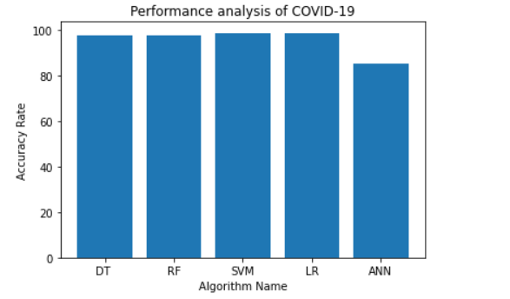
Accuracy = Number of Correctly Predicted Data Instances / Total Number of Data Instances (5)
FIGURE.4.a Performance of Covid-19
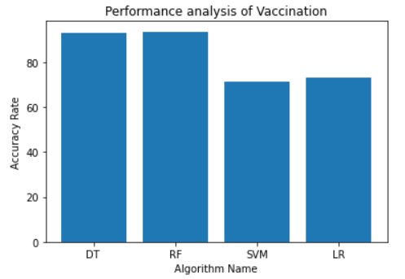
FIGURE.4.b Performance of Vaccination

[23]Root Mean Squared error is calculated by the square root of summation of difference between predicted cases with actual cases to the fraction of number of samples taken and it is given by the equation (6),
RMSE=$\sqrt[2]{\frac{1}{N}} \sum_{i=1}^{n}{}{Predicted}_{Covid-19 case(confirmed or death or recovered)}- {Actual}_{Covid-19 case(confirmed or death or recovered)}$ (6)

TABLE.1. MAE, MSE, RMSE Values calculated

Machine Learning Models | MAE | MSE | RMSE
Random Forest | 0.2155782728104974 | 3.5596391516631063 | 1.886700599369997
Decision Tree | 0.20068359375 | 5.78515625 | 2.405235175611732
Multi Linear Regression | 0.31930644577904366 | 16.463761504108447 | 4.05755609993361
Support Vector Machine | 0.503763987792472 | 17.581281790437437 | 4.193003910138582

In order to evaluate the regression performance of the model is determined by Mean Absolute Error, Mean Squared Error and Root Mean Squared Error. Mean Squared Error is the easiest evaluation method, which can be interpreted easily. Table.1. shows the MAE is defined by the average variance between true and predicted values. Also, it is residual average in the dataset. MAE is called by difference between predicted value to the actual value, which is an absolute value taken from the error, and finally it is summed up before taking into average of it. MAE is always be closer to 0.
$MAE = \frac{1}{N}\sum_{i=1}^{N}{}\left|y_{i}- \hat{Y}\right|$ (7)

Where, $\hat{Y}$ is the predicted value of y and y is the mean value. It is widely used with dataset which have outliers. MAE graph is not differentiable, in order to make it, various optimizers are applied. MSE is defined by the average of its squared difference between actual value to the predicted value in the datasets. Also, it is the residual variance. MSE can be calculated by,
$MSE = \frac{1}{N}\sum_{i=1}^{N}{}{\left|y_{i}- \hat{Y}\right|}^{2}$ (8)

Most disadvantage of using MSE is that, if the dataset have outliers, then it penalizes. Also, if the output variable is in meter, then calculating the MSE’s output also get squared. The MSE graph is differentiable, hence can be used easily for the loss function. RMSE is the mean squared errored square root. It is defined by the standard deviation of its residuals.
$RMSE =\sqrt{\frac{1}{N}\sum_{i=1}^{N}{}{\left|y_{i}- \hat{Y}\right|}^{2}}$ (9)

Root Mean Squared Error is mostly used to estimate the regression model performance of the models along with the dependent variable of same units as Y- axis. It is default performance metric for loss function calculation. RMSE is an optimization parameter with a training, which is faster computation metric compared to. It is not widely used for dataset with outliers. Mean Squared Error is the distinguishable function which is to perform the mathematical comparison to the non-differentiable functions.
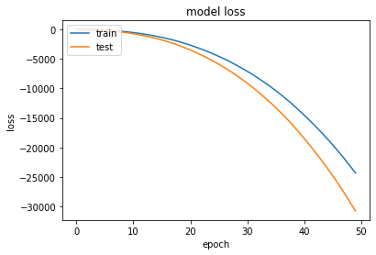
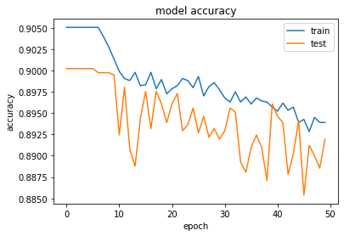
Vaccination data was pre-processed in the same way, with missing values being replaced with mean values. After that, it's separated into data that's been trained and data that's been tested. Following that, the machine learning techniques were implemented and the accuracy was acquired. FIGURE.4.b. shows that performance analysis of vaccination data of different states with ML algorithms as in X-axis and accuracy rate is at Y-axis. The acquired accuracy for the algorithms for vaccination data are as follows, Decision Tree (93.23), Linear Regression (73.12), and SVM (71.57). With 93.66, Random Forest has the highest accurate of the bunch.
FIGURE.5. Accuracy and Loss Model
Artificial neural network (ANN) technique for the same covid19 data has been implemented in deep learning, Table.2. and Table.3. the training and testing data were split in the ratio of 0.33 and the accuracy is approximately from 87% to 93%. At different epochs and batch sizes of 16 and 32, the training and validation accuracy is obtained. When epoch is equal to 50, the maximum accuracy is obtained as 0.9247. FIGURE.4.a. Finally, a graph for performance analysis was created Similarly, the obtained results of ANN models are experimented with different epochs and batch size. FIGURE.5. shows that the graphical representation of ANN model for Covid-19 data. When epoch is between 1 to 10, it maintains the accuracy range of 0.9050 and after 11 epochs, the accuracy is in between 0.88 to 0.90. As for the testing the model, the accuracy is in the range between 0.88 to 0.90. FIGURE.5. represents the training loss and testing loss is gradually decreasing for 50 epochs.

TABLE.2. Accuracy and loss of training and validation data, when batch size = 32

Epochs | loss | accuracy | val_loss | val_accuracy
50 | -5559.1562 | 0.8939 | -7007.5664 | 0.8919
100 | -96064.0859 | 0.8907 | -119161.7422 | 0.8881
150 | -645974.6875 | 0.8898 | -798054.5000 | 0.8871

TABLE.3. Accuracy and loss of training and validation data, when batch size = 16
Epochs | loss | accuracy | val_loss | val_accuracy
50 | -15273037.0000 | 0.8715 | -18867434.0000 | 0.8698
100 | -16190388.0000 | 0.8712 | -19884038.0000 | 0.8688
150 | -15361828.000 | 0.8698 | -18976420.0000 | 0.8696

1.7 Analysis of before and after Covid-19 Vaccination
The accuracy analysis of covid19 mortality, recovered and confirmed cases before and after immunization is demonstrated using the various approaches.Fig.5. SVM, Decision Tree, Random Forest, and Multi Linear Regression are the machine learning algorithms involved in this case analysis. This makes interpreting the covid19 before and after immunization much easier. From this graphical representation, it can be concluded that people getting affected by the corona virus gradually decreases and also morality rate decreases progressive. In FIGURE.6. blue-colored represents the before vaccination number of covid case count and the orange-colored bar represents after vaccination, covid case count. All the four algorithms produce almost same accuracy, while calculating before vaccination covid count but in after immunization it doesn’t produce accurate results. There are some losses in the algorithms because of imbalanced data available.
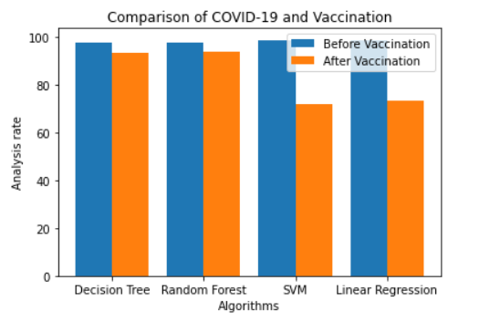
FIGURE.6. Graphical representation of before and after Covid-19 Vaccination
1.8 Conclusion
This progress looked at how the COVID-19 spread across India and developed a methodology for analyzing the number of confirmed, recovered, and mortality cases, as well as cases following vaccination. Multiple linear regression, SVM, Decision tree, Random Forest, are used for analyzing, upon those SVM gives the highest accuracy of 98%. For prediction and accuracy, an artificial neural network is utilized for vaccination analysis. A graph depicting the instances that happened before and after immunization is also included. This analysis might be useful for resource management, such as health care, and prompt action could be performed with advance planning to decrease human life loss. The suggested model might be used to forecast which may lead the epidemic to stop in a certain location. With the aid of this model, total causation and total economic losses may be projected.
References
1. Wu, S.C., Progress and concept for COVID‐19 vaccine development. Biotechnology journal, 2020.
2. Kumar, R., et al. COVID-19 Outbreak: An Epidemic Analysis using Time Series Prediction Model. in 2021 11th International Conference on Cloud Computing, Data Science & Engineering (Confluence). 2021. IEEE.
3. Xiao, J., et al., SARS, MERS and COVID-19 among healthcare workers: A narrative review. Journal of infection and public health, 2020. 13(6): p. 843-848.
4. Antiochia, R., Nanobiosensors as new diagnostic tools for SARS, MERS and COVID-19: from past to perspectives. Microchimica Acta, 2020. 187(12): p. 1-13.
5. Chowdhury, M.E., et al., An early warning tool for predicting mortality risk of COVID-19 patients using machine learning. Cognitive Computation, 2021: p. 1-16.
6. Graham, B.S., Rapid COVID-19 vaccine development. Science, 2020. 368(6494): p. 945-946.
7. Corey, L., et al., A strategic approach to COVID-19 vaccine R&D. Science, 2020. 368(6494): p. 948-950.
8. Kumari, R., et al., Analysis and predictions of spread, recovery, and death caused by COVID-19 in India. Big Data Mining and Analytics, 2021. 4(2): p. 65-75.
9. Saini, S.K., et al. Visual exploratory data analysis of covid-19 pandemic. in 2020 5th IEEE International Conference on Recent Advances and Innovations in Engineering (ICRAIE). 2020. IEEE.
10. Mandel, M., et al., Cytokine prediction of mortality in COVID19 patients. Cytokine, 2020. 134: p. 155190.
11. Gambhir, E., et al. Regression analysis of COVID-19 using machine learning algorithms. in 2020 International conference on smart electronics and communication (ICOSEC). 2020. IEEE.
12. Zagrouba, R., et al., Modelling and simulation of COVID-19 outbreak prediction using supervised machine learning. Computers, Materials, & Continua, 2021: p. 2397-2407.
13. Kumar, S., et al., COVID-19 Data Analysis and Prediction Using (Machine Learning) and Vaccination Update of India. Available at SSRN 3847564, 2021.
14. Shahid, F., A. Zameer, and M. Muneeb, Predictions for COVID-19 with deep learning models of LSTM, GRU and Bi-LSTM. Chaos, Solitons & Fractals, 2020. 140: p. 110212.
15. Parbat, D. and M. Chakraborty, A python based support vector regression model for prediction of COVID19 cases in India. Chaos, Solitons & Fractals, 2020. 138: p. 109942.
16. Pahar, M., et al., COVID-19 Cough Classification using Machine Learning and Global Smartphone Recordings★. Computers in Biology and Medicine, 2021: p. 104572.
17. Hany, N., et al. Detection COVID-19 using Machine Learning from Blood Tests. in 2021 International Mobile, Intelligent, and Ubiquitous Computing Conference (MIUCC). 2021. IEEE.
18. Rustam, F., et al., COVID-19 future forecasting using supervised machine learning models. IEEE access, 2020. 8: p. 101489-101499.
19. Matos, M.E.V. and A. de Vasconcelos Montenegro, Conteúdos e metodologias aplicadas nas aulas de educação física e contribuição do psicólogo durante a pandemia COVID-19. Brazilian Journal of Development, 2021. 7(4): p. 35366-35379.
20. Bhadana, V., A.S. Jalal, and P. Pathak. A Comparative Study of Machine Learning Models for COVID-19 prediction in India. in 2020 IEEE 4th Conference on Information & Communication Technology (CICT). 2020. IEEE.
21. Chmielewski, M.R. and J.W. Grzymala-Busse, Global discretization of continuous attributes as preprocessing for machine learning. International journal of approximate reasoning, 1996. 15(4): p. 319-331.
22. Aljameel, S.S., et al., Machine Learning-Based Model to Predict the Disease Severity and Outcome in COVID-19 Patients. Scientific Programming, 2021. 2021.
23. Dhamodharavadhani, S., R. Rathipriya, and J.M. Chatterjee, COVID-19 Mortality Rate Prediction for India Using Statistical Neural Network Models. Frontiers in Public Health, 2020. 8(441).

